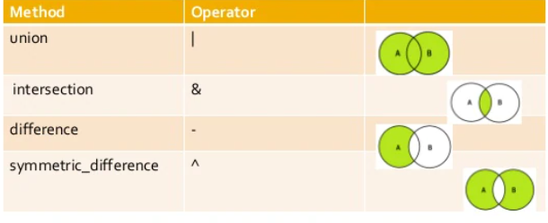

* The //​ operator performs integer division.

The % operator performs integer division remains.

x, y = ​7​, ​2 🡺 x // y : 3 x % y : 1